Project Name: Myntra

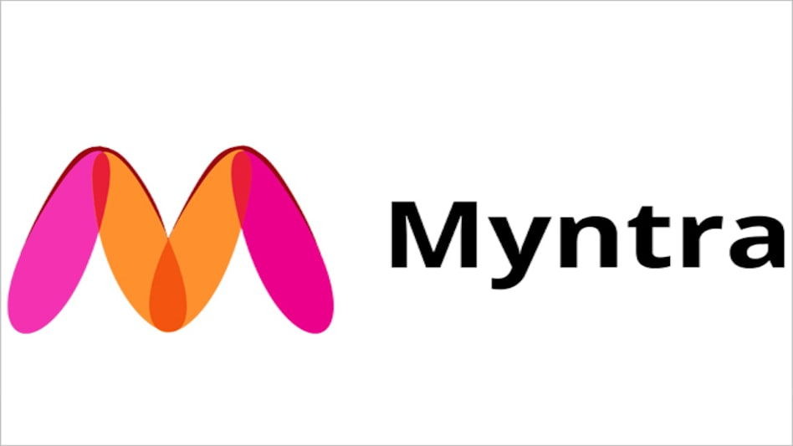

Overview:

Myntra is a one stop shop for all your fashion and lifestyle needs. Myntra is an e-commerce store for fashion and lifestyle products. Myntra aims at providing a hassle free and enjoyable shopping experience to shoppers across the country with widest range of brands and products on its portal.

Technologies Used:

* HTML
* CSS
* JavaScript
* React
* Node js
* Mongodb

Home Page:

* Logo
* Tab(Men, Women, Kids, Home & Living, Beauty, Studio)
* Search bar
* Icons(Profile, Wishlist, bag)
* Banner(Image)
* Deals(Images)
* Footer(Online Shopping, Customer Policies, Useful Links, Links to mobile App, Social media links)

Login/SignUp Page:

Login Page:

* Mobile Number
* Verify OTP

Sign Up:

* Mobile Number
* Verify OTP
* Create New Account
* Enter details(Password, Name, Gender, Alternate mobile number, Email-id)
* Create Account

Main Page:

* Filters(Color, Brand, Categories, Price Range, Discount range)
* Sort(Recommended, What’s new, Popularity, Better Discount, Price: High to Low, Price: Low to High, Customer rating)
* Image of chosen product(Brand, Size, Price)
* On clicking image(Multiple image of product will appear from different angle, Zoom in, Zoom out)

Product Page:

* Description of product
* Add to wishlist
* Add to bag

Payment Page:

* Address Selection
* Payment option(PhonePe, Google Pay, UPI ID, Credit/ Debit Card, Paytm/Wallets, Net Banking, EMI/Pay Later, Cash on Delivery)